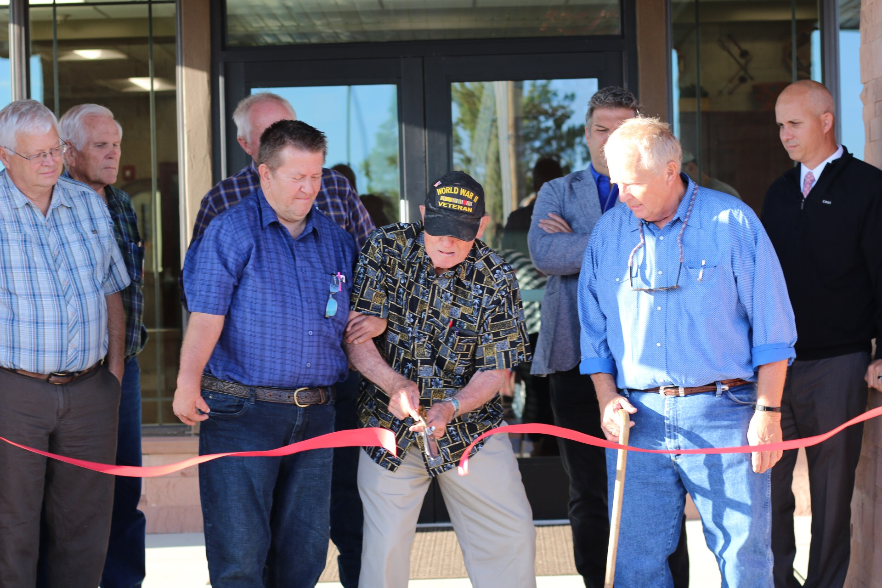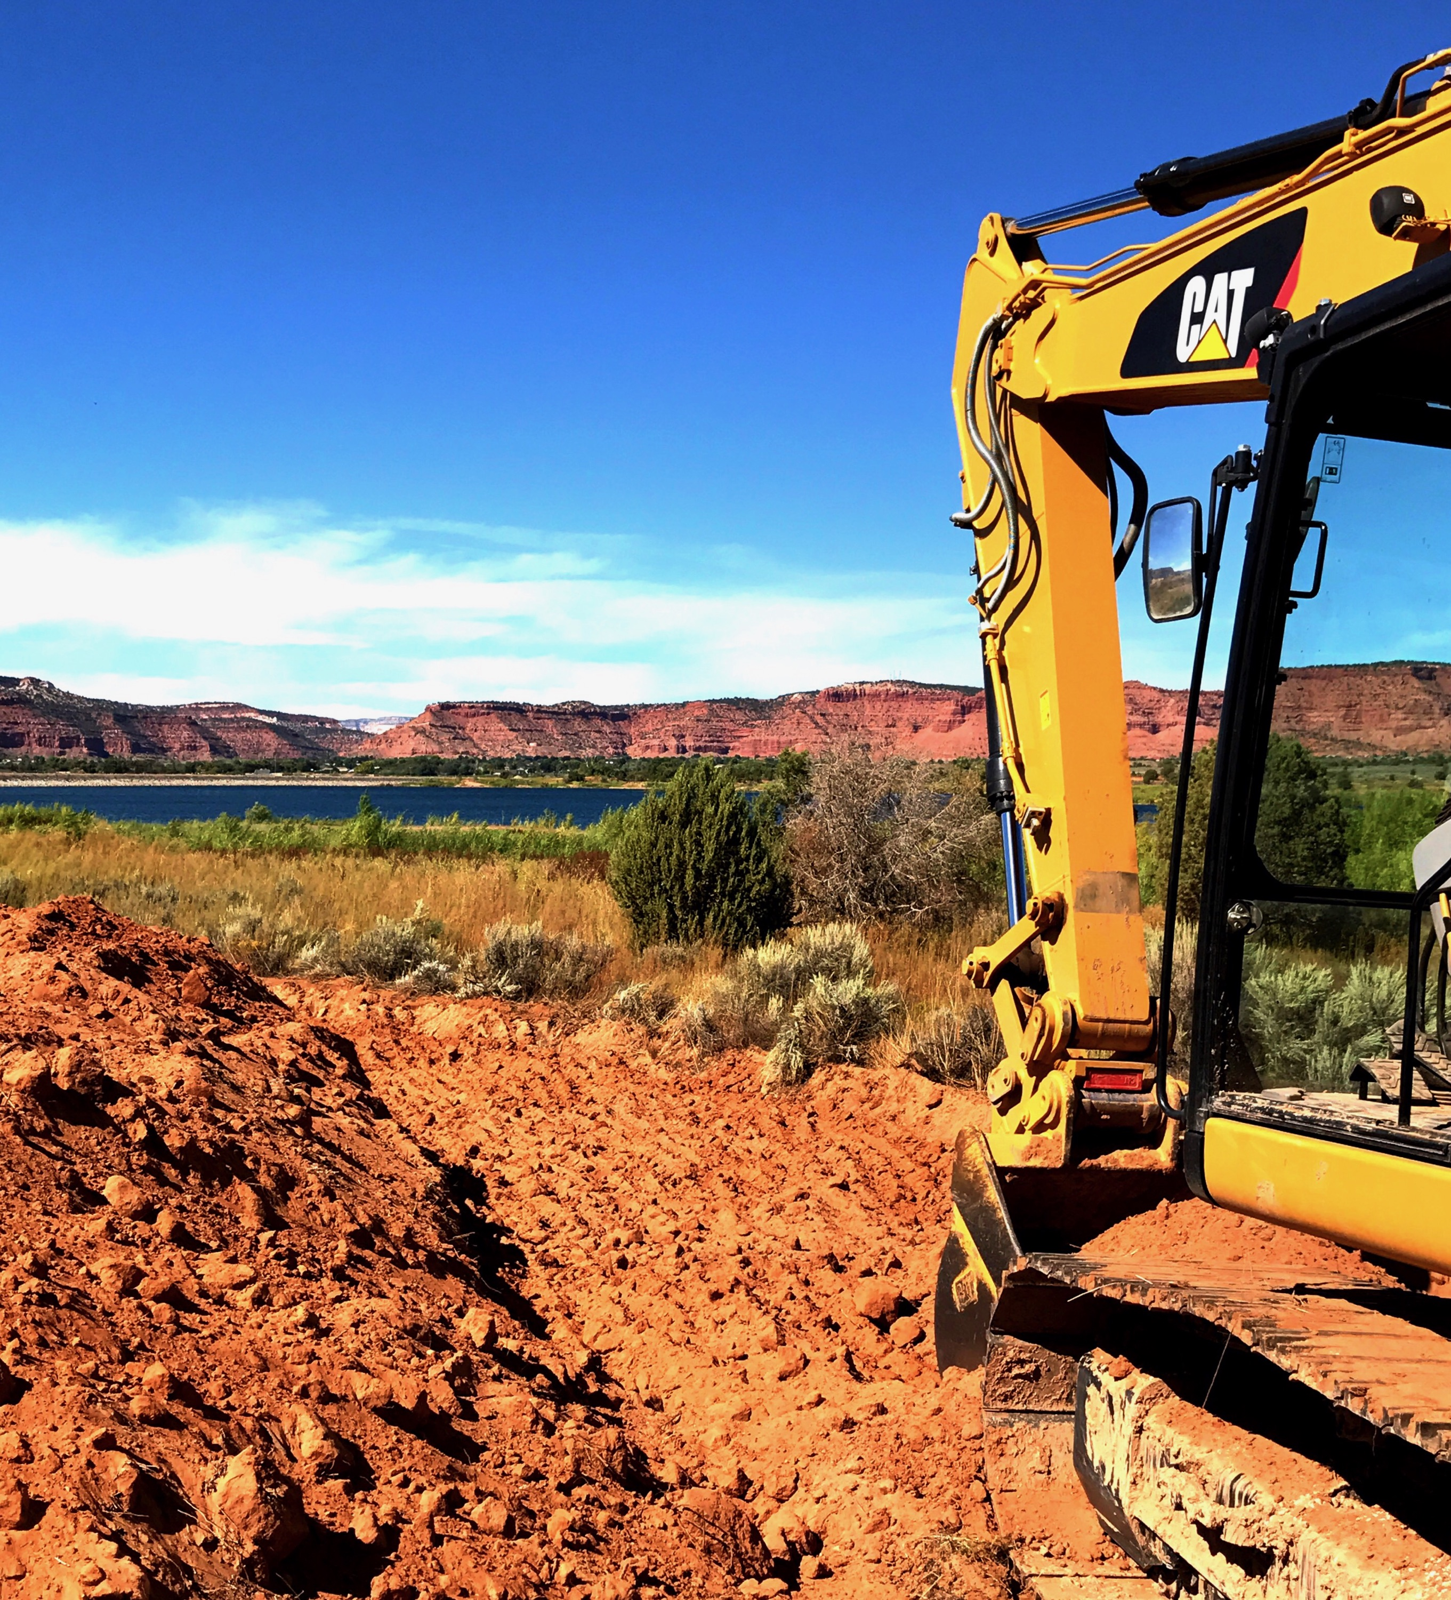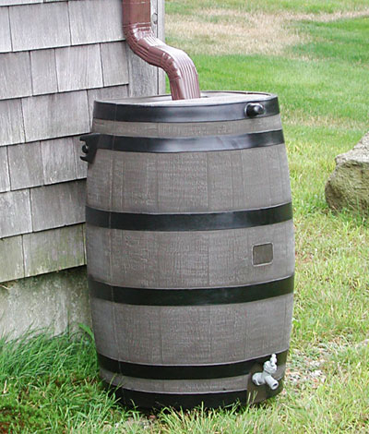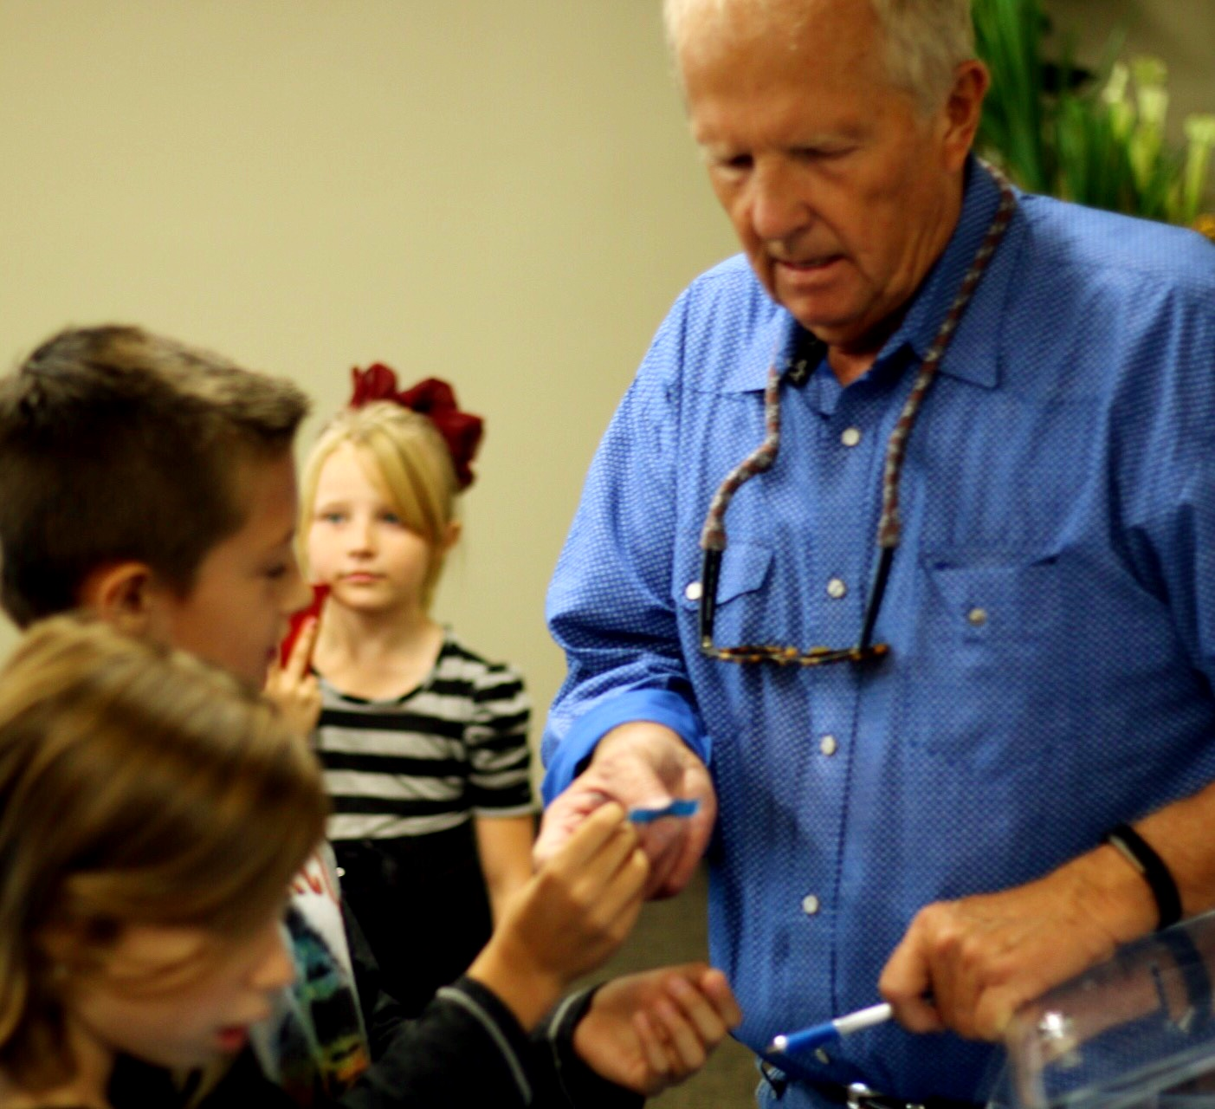

##### Office Hours

##### Holiday Closure

# KCWCD Celebrates 25 Year Anniversary & Open House

Cloyd Chamberlain, the only current board member that was on the original board when KCWCD was organized, cuts the red ribbon for the open house of the new KCWCD office building. Over 100 people showed up for the celebration. Hamburgers and hot dogs were served to people in attendance. Door prizes such as knives, bullets, gift certificates, fit-bits, a sound box, a cooler and a flat screen tv were raffled off. KCWCD would like to thank all that attended and contributed in what was an awesome event.

### Construction On The Sherry Belle Tail Begins

KCWCD acquired grant money from the department of recreation to construct an asphalt path to border the Jackson Flat Reservoir. The path will be used for walking/running, biking, skating, etc. The trail is to be named after Mike Noel’s late wife Sherry. The trail distance around the main trail will be an exact 5k with the addition of two loops that branch off of the main trail adding approximately one extra mile of trail. The trail will be open for all public to use and will prove to be an amenity for Kane County that both locals and tourists will use frequently for time to come. The trail is to be completed before December 2017.

#### Announcements

Columbus: 10/09

Veterans: 11/10

Thanksgiving: 11/23,24

Christmas: 12/25,26

##### Board Meetings

10/12/17 – 7:00 PM

11/9/17 – 6:00 PM

12/14/17 – 6:00 PM

9:00 am – 5:00 pm

Monday – Friday

Closed: Sat & Sun

KCWCD PIPELINE

### the

Kane County Water Conservancy District

Fall 2017

**Like our Facebook**

**@ Kane County Water Conservancy District**

**Follow us on Twitter**

**@ KCWCD**

* Put a barrel underneath the gutter or outside to gather rainwater and use that on plants and your landscape.
* Only water as fast as the ground will absorb the water to avoid runoff.
* Use a broom instead of a hose to clean driveways and sidewalks.

Or

KCWCD held a water conservation incentive contest to reward the top 2 customers that saved the highest percentage of water in the summer months (July, August, September) of 2016 to the same 3 months in 2017 with their choice of either a rainwater harvest barrel or a $100 credit toward their bill. Of course, KCWCD would love to see the winners select the rainwater harvest barrel in order to recycle water for outdoor use on your properties, but understand if you take the money. In the state of Utah, property owners are legally allowed to collect and store precipitation without registering in no more than two covered storage containers if neither covered container has a maximum storage capacity of greater than 100 gallons. If you would like to harvest more water you can up to 2,500 gallons but registration with the state is required. Congratulations to Steven Kidd for Saving 68% and to Glen Hardison for saving 87%. These two customers will be rewarded for their water conservation efforts. KCWCD would like to encourage all customers to make a conscious effort to conserve water this upcoming year, especially during the summer when customers use more water.

Congratulations to

Steven Kidd & Glen Hardison

## Water Conservation Incentive

# Meet the Staff

Mike Noel

In 1992, Mike was appointed by the Kane County Commission as one of the six members of the Board of Trustees of the newly formed KCWCD. The district was formed after an overwhelming vote of the citizens to not only to establish the district but to agree to a property tax to support the new district. In 1996 the Executive Director position for the KCWCD was vacated. Mike applied for the position and was hired by the board. Mike works to develop, improve, and increase the water resources of Kane County. Mike enjoys spending time with his family and working on his ranch.